**Azure App Services**

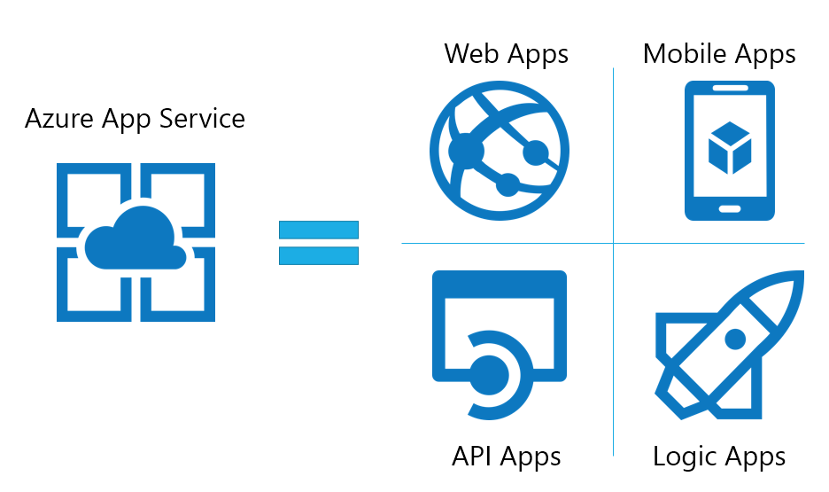

Azure App Services is a **Platform as a Service (PaaS)** offering that enables you to build, host, and scale web apps, RESTful APIs, and mobile backends. It abstracts infrastructure management, letting you focus on code and business logic.

Features :

1. No need to manage servers or VMs.
2. Auto-scaling and load balancing built-in.
3. Built-in support for .NET, Node.js, Java, Python, etc.
4. DevOps integration, CI/CD, staging slots.
5. Focus is on **code, not infrastructure.**

**Azure App Services abstracts infrastructure and provides a managed environment for app development**, which is the core principle of **PaaS**.